Evaluation Report

**Cumali MANSUROGLU - 2508521 - cumalimansuroglu@metu.edu.tr**

**Batuhan Sarıaslan - 2508604 - batuhan.sariaslan@ metu.edu.tr**

**Yunus Teke – 2508638 - yunus.teke@metu.edu.tr**

**Muhammed Sinan - 2508620 - muhammed.sinan@metu.edu.tr**

**Aryana Nejadi - 2489748 - e248974@metu.edu.tr**

Executive Summary

This executive summary provides a concise overview of the evaluation report on a course created using Articulate Storyline, focusing on teaching teachers about the Kialo web tool and analytic thinking. The report discusses the practical implementation of the course, including usability testing and gathering feedback through a course evaluation form. Based on user feedback and evaluations, iterative improvements were made to enhance the course's design and user experience. The evaluations played a crucial role in refining the course, resulting in a more effective and impactful learning experience. The report highlights the significance of user feedback in creating a high-quality educational course, empowering teachers with the necessary knowledge and skills to incorporate Kialo and analytic thinking into their classrooms.

Methods used to evaluate the instruction

The procedures used for the formative and summative evaluation and revision of the instructional products are described. The report focuses on the assessment and improvement of a course developed using Articulate Storyline, which aims to educate teachers about the Kialo web tool and analytic thinking. The initial course design was based on theoretical knowledge, but user feedback and evaluations were crucial in identifying areas for improvement. The design was refined by adhering to design principles, ensuring a modern and user-friendly interface. Usability testing was conducted, allowing participants to explore the course independently, and their feedback and observations were carefully considered to make further improvements. Participants also completed a course evaluation form, providing feedback on various aspects of the course. The evaluations and feedback received led to iterative improvements, resulting in an enhanced and more impactful course. Appendices in this report include the questions used in evaluations, users' statements, videos, photographs, sound recordings, and instruments such as usability tests, surveys, and interviews, providing evidence of the evaluation process. Overall, this report highlights the significance of user feedback in refining instructional products and creating a high-quality educational experience for teachers.

Findings from formative evaluation

Based on the feedback we received during the formative evaluation, we have made significant enhancements to two designs. In both designs, we have made notable improvements in terms of the overall theme, content, questions, feedback mechanisms, as well as the quality of video and voice recordings. The following modifications have been implemented based on the two designs:

Design 1:

We carefully analyzed the feedback we received, particularly from Taner Zorbay, to identify areas for improvement. One key aspect that demanded our attention was the introduction section. Taner Zorbay rightly pointed out that it contained an excessive amount of paragraphs, potentially overwhelming users. Recognizing the importance of creating a captivating first impression, we took immediate action to revamp the introduction.

To address the issue of excessive text, we meticulously reviewed and edited the content, ensuring that it conveyed the necessary information concisely and effectively. By condensing the paragraphs and adopting a more streamlined approach, we aimed to captivate users from the very beginning and ensure a smoother user journey.

Another aspect that came under scrutiny was the size of the picture accompanying the introduction. Taking Taner Zorbay's feedback into account, we recognized the need for a visually striking image that would leave a lasting impact. Consequently, we made the decision to replace the original small picture with a larger, more visually appealing one. This change not only enhanced the aesthetic appeal but also served to better engage users and create a memorable visual experience.

Additionally, the feedback regarding the buttons on the design prompted us to reevaluate their appearance and usability. Taner Zorbay rightly observed that the blue buttons clashed with the background, creating a visually inconsistent and potentially distracting interface. To address this issue and maintain a cohesive design language, we made the deliberate choice to change the button color to purple. This adjustment not only ensured visual harmony but also improved the overall user experience by providing a more seamless and aesthetically pleasing interface.

In summary, armed with the valuable feedback from Taner Zorbay, we made significant strides in improving the design. By carefully considering the concerns regarding excessive text in the introduction, replacing the small picture with a more impactful one, and enhancing the button color for visual consistency, we aimed to create an immersive and visually appealing experience that resonates with users and elevates the overall design quality.

Design 2:

In the final stage of our design process, we dedicated our efforts to optimizing the teaching material based on the valuable feedback provided by Taner Zorbay. Recognizing the importance of creating engaging and visually appealing content, we carefully reviewed the suggestions and made significant improvements to enhance the overall user experience.

One notable enhancement we implemented was the addition of completed signs. Understanding the significance of clear and concise indicators, we introduced completed signs strategically throughout the teaching material. These signs serve as visual cues, providing users with a sense of progress and accomplishment as they navigate through the content. By incorporating these signs, we aimed to enhance user motivation and provide a sense of satisfaction as users engage with the material.

Moreover, we paid close attention to the visual aspects of the teaching material. Taking into account the feedback from Taner Zorbay, we identified areas where visual changes could be made to further enhance the appeal of the content. This involved refining the layout, typography, color scheme, and imagery to create a visually captivating experience. By making these visual changes, we sought to capture users' attention, improve information retention, and facilitate a more enjoyable learning process.

Through this iterative design process, guided by the valuable input from Taner Zorbay, we aimed to optimize the teaching material to its fullest potential. By introducing completed signs and implementing visual improvements, we strived to create an engaging and visually appealing learning experience that not only meets user expectations but also fosters a positive and rewarding learning journey.

Findings from summative evaluation

The first usability test – Mert Tekin

The obtained data from the test, which had an average duration of 30 minutes, can be summarized as follows. Mert expressed that the design of the slides was captivating and extraordinary. It was also noted that the minor design choices contributed to Mert's improved focus. The writing style was found to be engaging by Mert. The questions presented during and after the lecture proved to be successful as a teaching method. Furthermore, Mert highly appreciated the comprehensive feedback provided for the questions, irrespective of the given answers. Mert also highlighted that the number of different question types used in the subject was insufficient. Additionally, the instructions and rubric provided for the end-of-course project were well-received, being considered detailed and explanatory. Mert found the program used in the course to be remarkably user-friendly, facilitating a seamless learning experience. In the course evaluation form, Mert mentioned the strengths and weaknesses of the e-learning material as follows: "The design decisions were initially impressive, but after some time, I became distracted and had difficulty maintaining proper focus on the topic. It was initially interesting, but it may have gradually lost some of its appeal."

Evaluation of the Second Usability Test – Can Baş

In the initial usability test, which lasted approximately 30 minutes, we collected feedback from participant regarding the usability of the e-learning material. Participant found the design of the slides to be attention-grabbing and remarkable. The small design decisions made were noted to improve the focus of the participant. However, one participant mentioned feeling distracted and unable to maintain proper focus on the topic after a while. This feedback suggests the need to ensure that the layout maintains user engagement throughout the material. The writing language used in the e-learning material was found to be interesting and engaging by participant. This indicates that the content was presented in a clear and understandable manner, facilitating the participant' comprehension. The use of terminology and language was effective in conveying the subject matter. Participant found the questions used during the lecture and at the end of the lecture to be successful as a teaching method. The comprehensive feedback provided regardless of the answer was highly appreciated. However, some participant pointed out that the number of different question types used in the subject was not sufficient. This feedback highlights the importance of incorporating a greater variety of questions to enhance the learnability of the content and maintain participant engagement. In addition to the specific feedback on layout, terminology, and learnability, participant praised the instructions and rubric provided for the project at the end of the course. They found them to be detailed and explanatory, which facilitated their understanding of the project requirements. Furthermore, the program used in the e-learning material was deemed very easy to use, creating a smooth learning experience for participant. To summarize, the first usability test provided valuable insights into the usability of the e-learning material. The layout design was generally attention-grabbing, although efforts should be made to sustain engagement over time. The terminology used was understandable and contributed to the overall interest in the content. The learnability of the material was enhanced through effective use of questions, but there is a need to incorporate a greater variety of question types. These findings will be considered for further refinement and improvement of the e-learning material to ensure optimal usability for future participant.

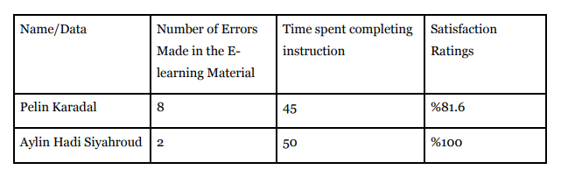

2

1

Can Baş

Mert Tekin

35

33

%79.8

%85

Revisions to be made to the instruction

We received predominantly positive feedback from the participants, with only a few minor concerns raised regarding the design. After careful consideration, we have decided not to make any changes to the design at this time. As a group, we believe that maintaining the current design decisions will be more beneficial for the students in the long term, even though implementing some changes could potentially enhance the user experience. One participant expressed that the material "lost some of its appeal," and we consider this feedback to be significant. As a result, we have decided to focus on improving the entertainment aspect of the project and will plan accordingly.

Timeline of the report

|  |  |  |  |
| --- | --- | --- | --- |
| Date | Task / Job | Time spent | Primary responsible member |
| 17.06.2023 | Appendix A and Appendix B | 1 week | Yunus Teke |
| 17.06.2023 | Findings from summative evaluation | 1 week | Batuhan Sarıaslan |
| 17.06.2023 | Executive Summary- Methods used to evaluate the instruction | 1 week | Cumali Mansuroğlu |
| 17.06.2023 | Findings from formative evaluation | 1 week | Muhammed Sinan |
|  |  |  | Aryana Nejadi |

References

This section should begin on a new page and include all of your references in the format shown below (APA 5th Ed.). Be sure to include website urls as well as journals, books, and chapters of edited books.

Brown, A., & Green, T. D. (2011). *The essentials of instructional design : connecting fundamental principles with process and practice*. Boston : Prentice Hall, 2011.

# Appendix A – Used tools and Collected Data for evaluation

metin, ekran görüntüsü, sayı, numara içeren bir resim

Açıklama otomatik olarak oluşturuldu**Mert Tekin - Questionnaire Answers**

metin, ekran görüntüsü, yazılım, sayı, numara içeren bir resim

Açıklama otomatik olarak oluşturuldumetin, ekran görüntüsü, yazı tipi içeren bir resim

Açıklama otomatik olarak oluşturuldumetin, ekran görüntüsü, sayı, numara içeren bir resim

Açıklama otomatik olarak oluşturuldumetin, ekran görüntüsü içeren bir resim

Açıklama otomatik olarak oluşturuldu

metin, ekran görüntüsü, yazı tipi içeren bir resim

Açıklama otomatik olarak oluşturuldu

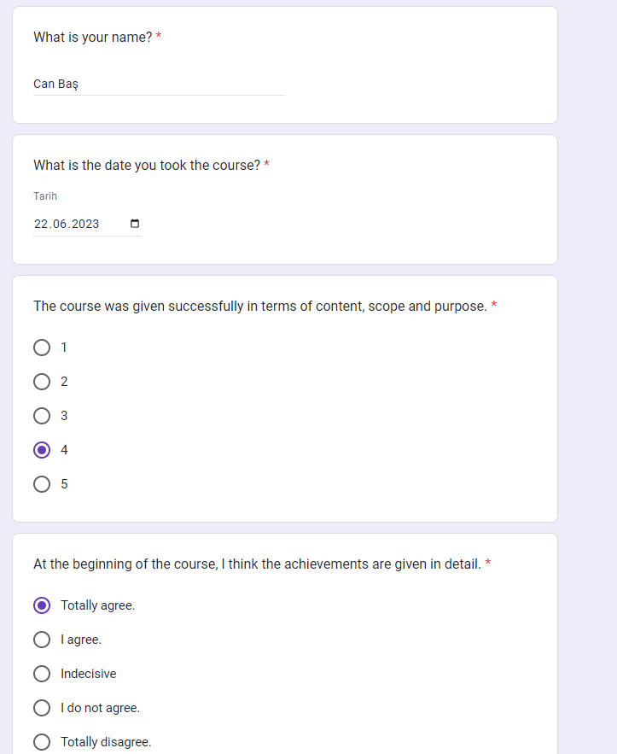

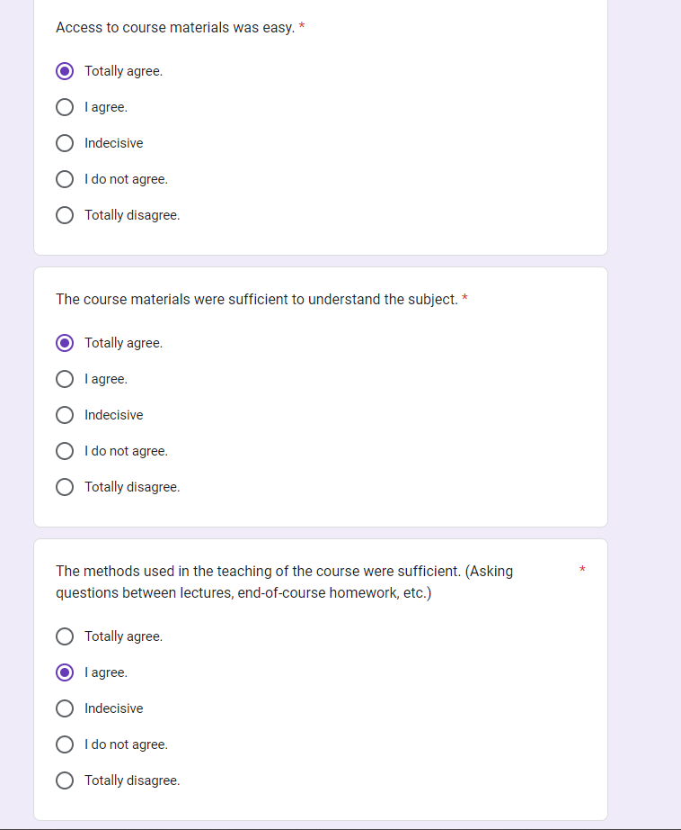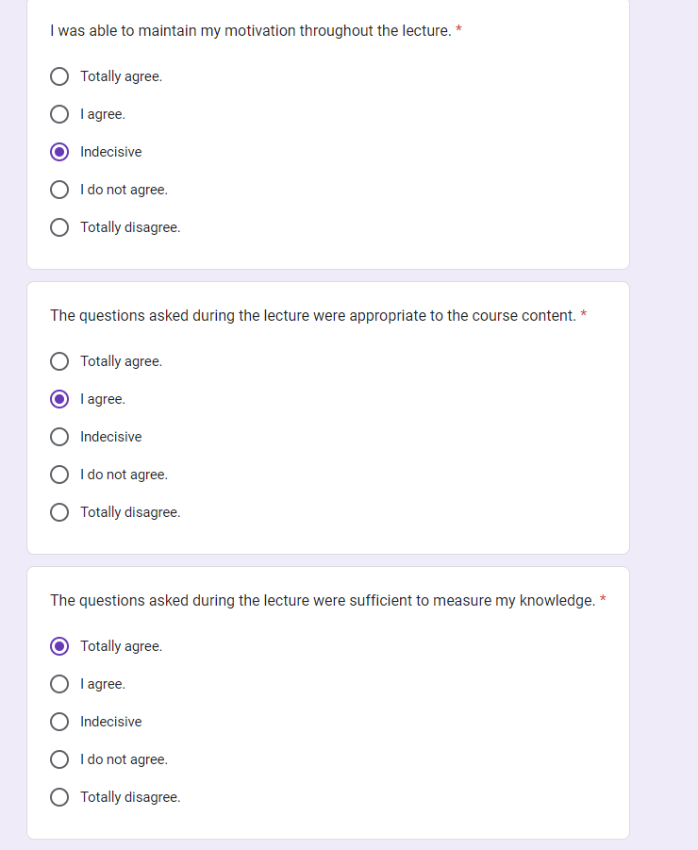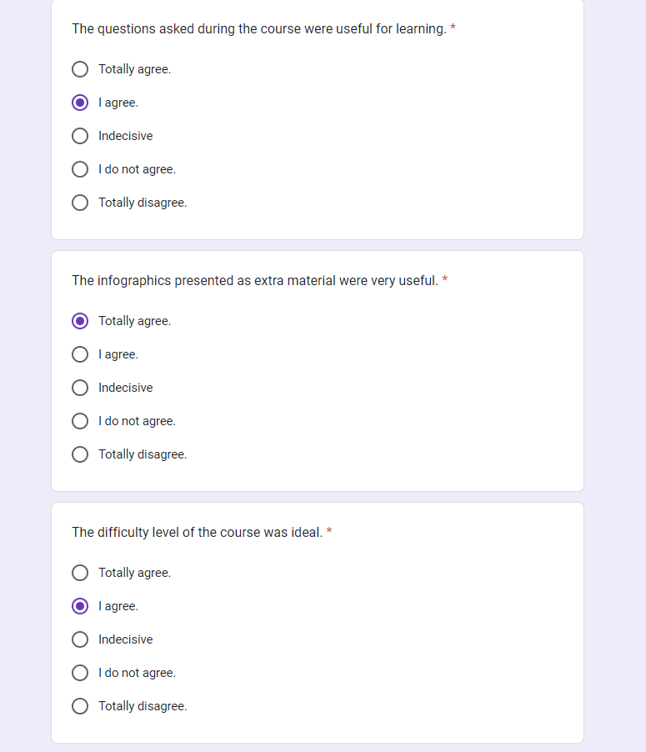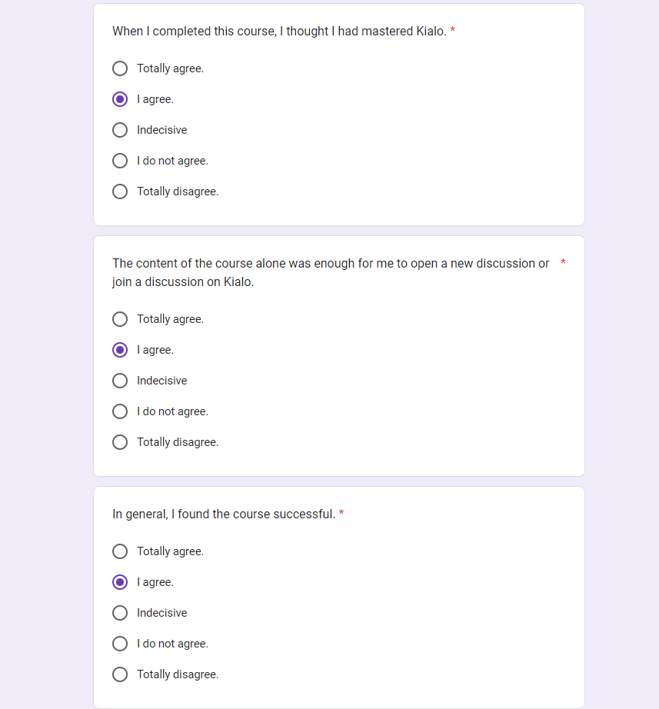

**Can Baş - Questionnaire Answers**





# Appendix B – Usability Test

Mert Tekin

Ankara University – English Language and Literature Junior Student

metin, ekran görüntüsü, yazılım, multimedya yazılımı içeren bir resim

Açıklama otomatik olarak oluşturuldu

metin, ekran görüntüsü, yazılım, bilgisayar simgesi içeren bir resim

Açıklama otomatik olarak oluşturuldu

Can Baş

Ankara University – Japanese Language and Literature Student Sophomore Student

